Ideation Phase
Empathize & Discover

Date | 29 July 2026
Team ID
Project Name | Plugging into the Future: An Exploration of Electricity Consumption Patterns
Maximum Marks | 4 Marks

Empathy Map Canvas:
An empathy map for "Plugging into the Future: An Exploration of Electricity Consumption Patterns" helps teams understand the needs, goals, and challenges of stakeholders such as energy providers, policymakers, researchers, and consumers. By analyzing their perspectives and concerns, the project identifies key issues in electricity usage, demand fluctuations, and energy efficiency. This user-centered approach enables the development of meaningful visualizations and data-driven insights that support better decision-making, sustainable energy planning, and effective electricity management.
Example:
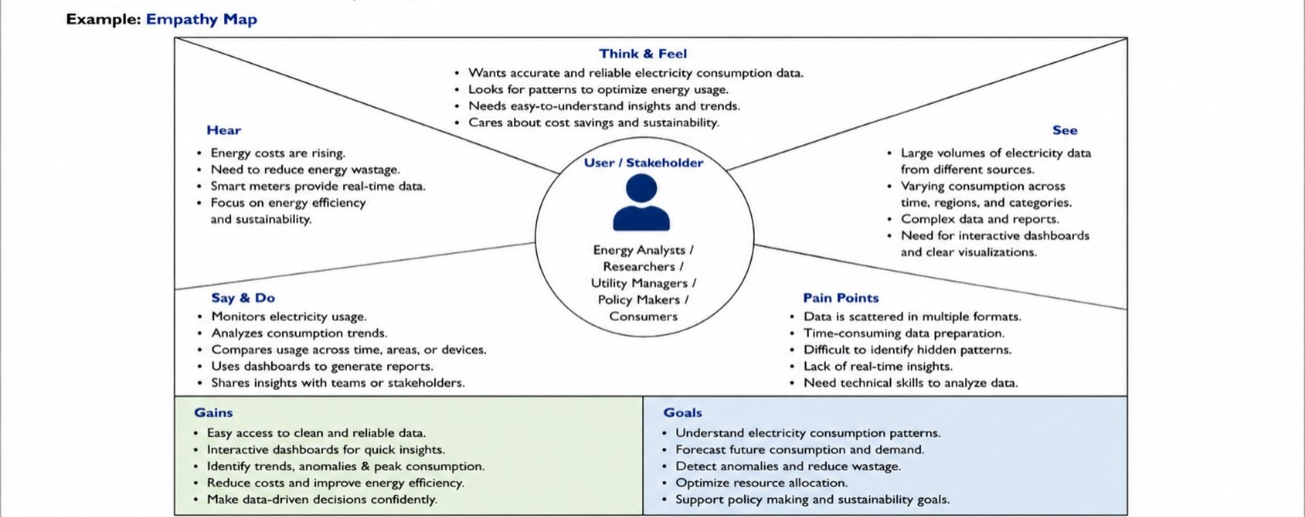
EMPATHY MAP CANVAS 